Esuabom Dijemeni

cERTIFIED SCRUM PROFESSION – ScRUM MASTER

Evidence File for CSP-SM

Table of Contents

1 Lean Agile and Scrum 2

1.1 LO 1-1 - Describe the origins of Lean Thinking 2

1.2 LO 1-2 Explain the core concept of Lean Thinking and how they can be applied to Scrum 3

1.3 LO 1-3 - Relate at least five wastes in product development to the seven wastes in Lean Manufacturing 5

1.4 LO 1-4 Relate at least three agile development practices to lean practices 6

2 Facilitation 7

2.1 LO 2-1 - differentiate at least three alternatives to open discussion. 7

2.2 LO 2-2 - identify at least three actions the facilitator can perform to support the development of an inclusive solution 8

2.3 LO 2-3 apply at least three visual facilitation techniques for a collaborative session. 9

2.4 LO 2-4 - identify at least three practices for facilitating remote meetings 11

2.5 LO 2-5 create a coaching agreement with an individual or a team- (living document). 11

2.6 LO 2-6 - discuss the importance of at least 2 fundamental coaching assumptions 12

2.7 LO 2-7 list at least three fundamental psychological concepts that help transform individual behaviour. 13

2.8 LO 2-8 - develop and teach at least one topic related to Scrum or Agile. 15

3 Service to Scrum Team 16

3.1 LO 3.1 - appraise at least two different models for team development 16

3.2 LO 3.2 compare at least 3 techniques for improving team effectiveness 18

3.3 LO 3-3 - describe at least five responsibilities for Scrum Team members and stakeholders when forming a new Scrum Team. 19

3.4 LO 3-4 - plan the launch of a new Scrum Team. 20

4 Service to the Product Owner 21

5 Service to the Organisation 21

6 Advanced Scrum Master 22

6.1 LO 6-1 Outline a personal development strategy toward Scrum Mastery 22

6.2 LO 6-2 practice mentoring someone. 23

# Lean Agile and Scrum

## LO 1-1 - Describe the origins of Lean Thinking

The roots of Lean can be found in the Japanese company of Toyota. Th e origins of Toyota Production System date back to the beginnings of the twentieth century. Th e fathers of the system was Sakichi Toyoda, his sons: Kiichiro Toyoda and Eiji Toyoda as well as Taiichi Ohno, a manufacturing engineer. Sakichi Toyoda, who then worked in textile industry, invented a motor-driven loom with a specialized mechanism devised to stop in case of breaking off the thread. The mechanism became later a foundation for Jidoka (automatization with human manufacturing), one of the two main pillars on which Toyota Production System was built. Due to the application of a fault detection sensor, the defects stemming from human-related imperfections were reduced and the production capacity was elevated.

In 1910, Sakichi Toyoda “visited the United States for the first time and realized that the new automotive era just was beginning” (Ohno T., 2008, translation mine, ŁD). Yet, the Toyoda family needed 20 years to materialize their plans. In 1929 Kiichiro Toyoda arrived in the USA with the aim of scrutinizing the local companies in the automotive industry. He was particularly fascinated with the Ford production system, which in 1913 introduced the serial production of its automobile (the T model) (Kornicki L., Kubik S., 2008, translation mine, ŁD). Consequently, when Toyota Motor Company initiated their production, Kiichiro decided to implement some of the resolutions he had witnessed in the USA. The then Japan suffered

from reduced demand, therefore diverse automobiles were necessarily produced in smaller numbers on the same assembly lines. In order to compete in the mass production automotive industry, which had already been introduced in European and American companies, Toyota was forced to change the methods of production. Kiichiro Toyoda fully understood the fact that it was mandatory to create a fast and flexible process of production as a result of which the clients would obtain desired, high-quality and reasonably-priced automobiles. Kiichiro commenced preparatory work to produce in the Just-in-time system. The objective of the latter was to elevate the production capacity and reduce waste painstakingly.

In the 1950s Sakichi’s son, Eiji Toyoda, visited the Ford company. It seems that owing to the visit Toyoda together with Taiichi Ohno were capable of creating a system linking the two pillars of the TPS (Jidoka and Just-in-time) with the Ford assembly line.

Shortly after the previous improvement Taiichi Ohno advanced another concept called “pull-flow production”, an old practice in American supermarkets. Th e pull-flow production allowed to generate as many products as could be exploited in the successive process. In turn, it would facilitate the reduction of overproduction.

The Toyota Production System did not arouse interest in Japanese and American companies by 1973. Not until the production had to be reduced, were Japanese and American managers capable of noticing significant outcomes that Toyota had achieved (Graczkowski S., 2008, translations mine, ŁD).

Reference

1. The Origins and Evolution of Lean Management System <https://www.jois.eu/files/DekierV_5_N1.pdf>

## LO 1-2 Explain the core concept of Lean Thinking and how they can be applied to Scrum

### Lean Principle

The 5 key principles of Lean Thinking are:

1. Identify value – Specify value from the standpoint of the end customer by product family
2. Map the Value Stream – Identify all the steps in the value stream for each product family, elimination whenever possible those steps that do not create value
3. Create flow – Make the value-creating steps occur in tight sequence so the product will flow smoothly toward the customer
4. Establish Pull – as flow is introduced, let customers pull value from the next upstream activity
5. Seek Perfection – repeat step 1 -4 until a state of perfection is reached in which perfect value is created with no waste

The core concept of Lean Thinking can be summarised:

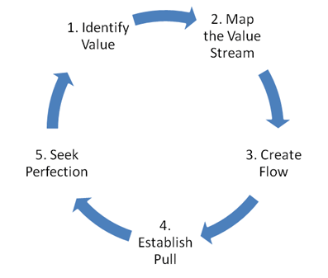

Figure - Lean Thinking Principles

### Lean Principle & Scrum

The table below summarises how Lean Principles are applied to Scrum

|  |  |
| --- | --- |
| **Lean Principle** | **Application in Scrum** |
| Identify Value | * Product Owner works closely with customers to understand the highest valuable product backlog items and ensure product backlog is prioritised in descending order of value (Highest priority items at the top of the backlog) |
| Map the value stream | * The scrum events provide an basic value stream map to ensure continuous value delivery to customers * User requirement -> Sprint planning -> daily scrum -> sprint review -> increment -> sprint retrospective -> repeat * As scrum is an incomplete process, additional steps can be added to ensure the value stream is fit for purpose |
| Creating Flow | * Daily Scrum helps the team to ensure that product backlog items are flowing as expected within every 24hrs * Sprint review ensures value flows to the customer every sprint (1-4 weeks). Thus, creating continuous value flow to customers * Scrum with Kanban provides a more robust way of creating continuous flow with Scrum Teams |
| Establish Pull | * The Scrum team pulls the highest priority product backlog items from the Product Backlog into the sprint backlog when capacity is available to ensure customers are getting the highest value item delivered |
| Seek Perfection | * Scrum team conduct sprint retrospective every sprint to ensure that the team is continuously improving, finding ways to decrease waste, and deliver value better |

Table - Lean Principles & Application in Scrum

Reference

1. Lean Thinking and Practice - <https://www.lean.org/lexicon-terms/lean-thinking-and-practice/>

## LO 1-3 - Relate at least five wastes in product development to the seven wastes in Lean Manufacturing

|  |  |
| --- | --- |
| **Waste in Lean Manufacturing** | **Waste in Product Development** |
| Transportation | * Switching between tasks too often * Countless interruptions from colleagues * Stakeholder continuously changing what value they want |
| Inventory | * Undelivered code * Undelivered features |
| Motion | * Unnecessary meetings * Extra effort to find information |
| Waiting | * Waiting for testing to complete * Waiting for code review * Waiting for requirements * Waiting for resources |
| Overproduction | * Producing features that nobody is going to use * Producing underutilised & undervalue features |
| Overprocessing | * Unnecessary complex algorithms solving simple problems * Processing large about of data with no significant benefit |
| Defects | * Bugs |

Table - Waste in Lean Manufacturing and Product Development

Reference

1. 7 wastes of Lean: How to Optimise Resources - <https://businessmap.io/lean-management/value-waste/7-wastes-of-lean>

## LO 1-4 Relate at least three agile development practices to lean practices

|  |  |
| --- | --- |
| **Lean Practices** | **Agile [Scrum] Practices** |
| Just in Time | * Ensuring the sprint product backlog has the most valuable product backlog items which are focused based on just in time sprint planning |
| Kaizen Continuous Improvement | * Sprint review provides the scrum team with customer feedback to inspect and adapt * Sprint retrospective ensure scrum team continuously improve individuals, interactions, processes, tools, and their Definition of Done |
| Build quality in | * Definition of Done * Test Driven Development * Behaviour Driven Development * Refactoring |
| Respect people | * Create shared working understanding * Create a People Culture * Create a continuous learning culture |
| Continuous Flow | * Continuous integration * Continuous delivery * Continuous deployment |

Table - Lean Practices & Agile [Scrum] Practices

Reference

1. Lean Principles 101 Guide - <https://www.planview.com/resources/guide/lean-principles-101/>
2. Scrum Guide - <https://scrumguides.org/scrum-guide.html#sprint-retrospective>

# Facilitation

## LO 2-1 - differentiate at least three alternatives to open discussion.

|  |  |  |
| --- | --- | --- |
| Activity | Process | Outcome |
| Structured Go-Around  (Round Robin) | * Go Around and give each person a brief turn to speak to a topic * Everyone else listens * When they finish, they pass it on to the next person until everyone has spoken and listened | * Increase conversion engagement * Empower introvert to speak up and extrovert to speak adequately * Improve active listening |
| Mind Mapping | * Create a visual diagram showing hierarchy, relationships, and ideas * Have a central focus from where ideas radiate out from * Ensure every team member contributes to the Mind Map * Employ visual whiteboarding tool – Miro, Mural or similar tool | * Capture diverse thinking * Visualise ideas and information better * Improves transparency |
| Brainstorming (Whiteboarding session) | * Provide an objective of the brainstorming session * Provide sticky note * Get the group to fill one idea per sticky note anonymously * Provide a timebox * Synthesis proposed ideas in a discussion * Take 1-3 action items | * Encourage creativity * Individual share thoughts without interruption and influence of others * Empower every individual to contribute * Preserving anonymity whilst facilitating sharing |

Table - Alternative to Open Discission

Reference

1. Go Around - <https://www.lucidmeetings.com/glossary/go-around>
2. Mind mapping - <https://www.adelaide.edu.au/writingcentre/sites/default/files/docs/learningguide-mindmapping.pdf>
3. What is brainstorming? <https://miro.com/brainstorming/what-is-brainstorming/>

## LO 2-2 - identify at least three actions the facilitator can perform to support the development of an inclusive solution

Actions a facilitator can perform to support a development of an inclusive solution are:

1. Ensure all voices are heard
2. Establish psychological safety
3. Create better meetings
4. Practice the mindset of neutral & impartial facilitator
5. Facilitate conversation through conflict
6. Helping scrum teams to understand and achieve their shared goals and objectives
7. Encourage people to explore different perspectives,
8. Encourage teams to harness diversity
9. Practise active listening
10. Encourage diverse curiosity

Reference

1. Agile Coaching Skills - Certified Facilitator (ACS-CF) - <https://www.scrumalliance.org/get-certified/agile-coaching-skills/certified-facilitator>
2. Facilitation - <https://www.scrum.org/learning-series/facilitation/>

## LO 2-3 apply at least three visual facilitation techniques for a collaborative session.

### Application 1 – Applied Visual Facilitation to help a Scrum Team Create Product Vision

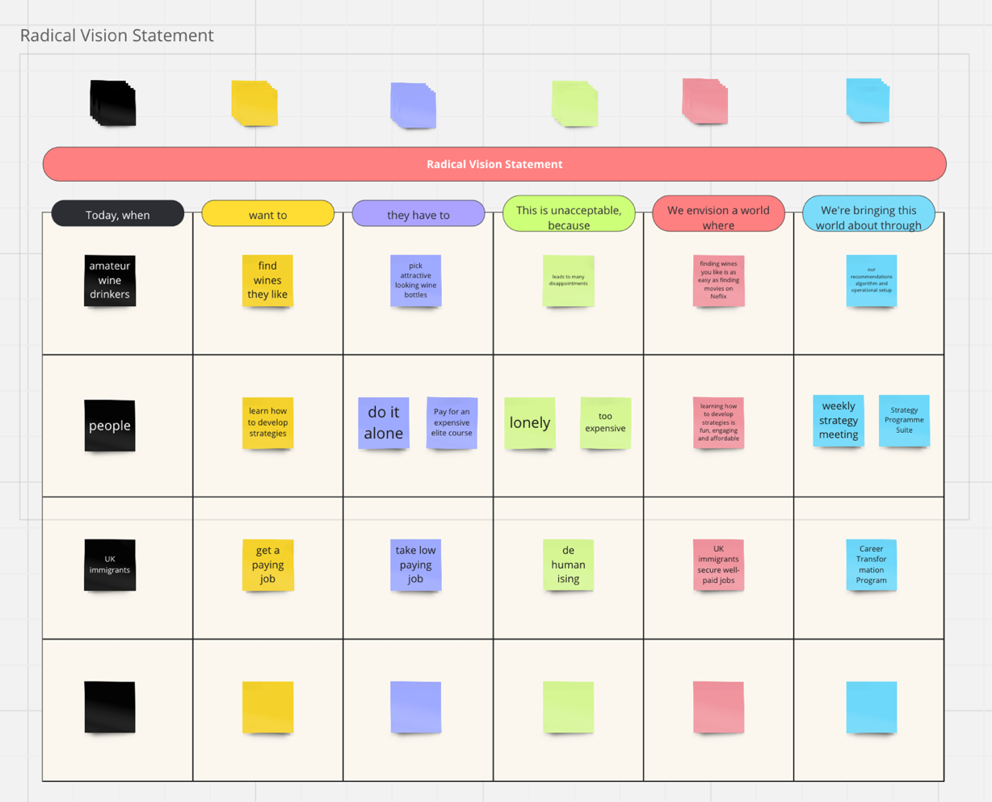

Figure - Facilitated a radical vision statement workshop using Miro for create better product vision

### Application 2 – Facilitated a visual persona creation workshop to help a Scrum Team understand their user better

Figure - Facilitated a visual persona creation workshop to help a Scrum Team understand their user better

### Application 3 - Facilitated a visual brainstorming workshop to help a Scrum Team better understand their product and organisation context

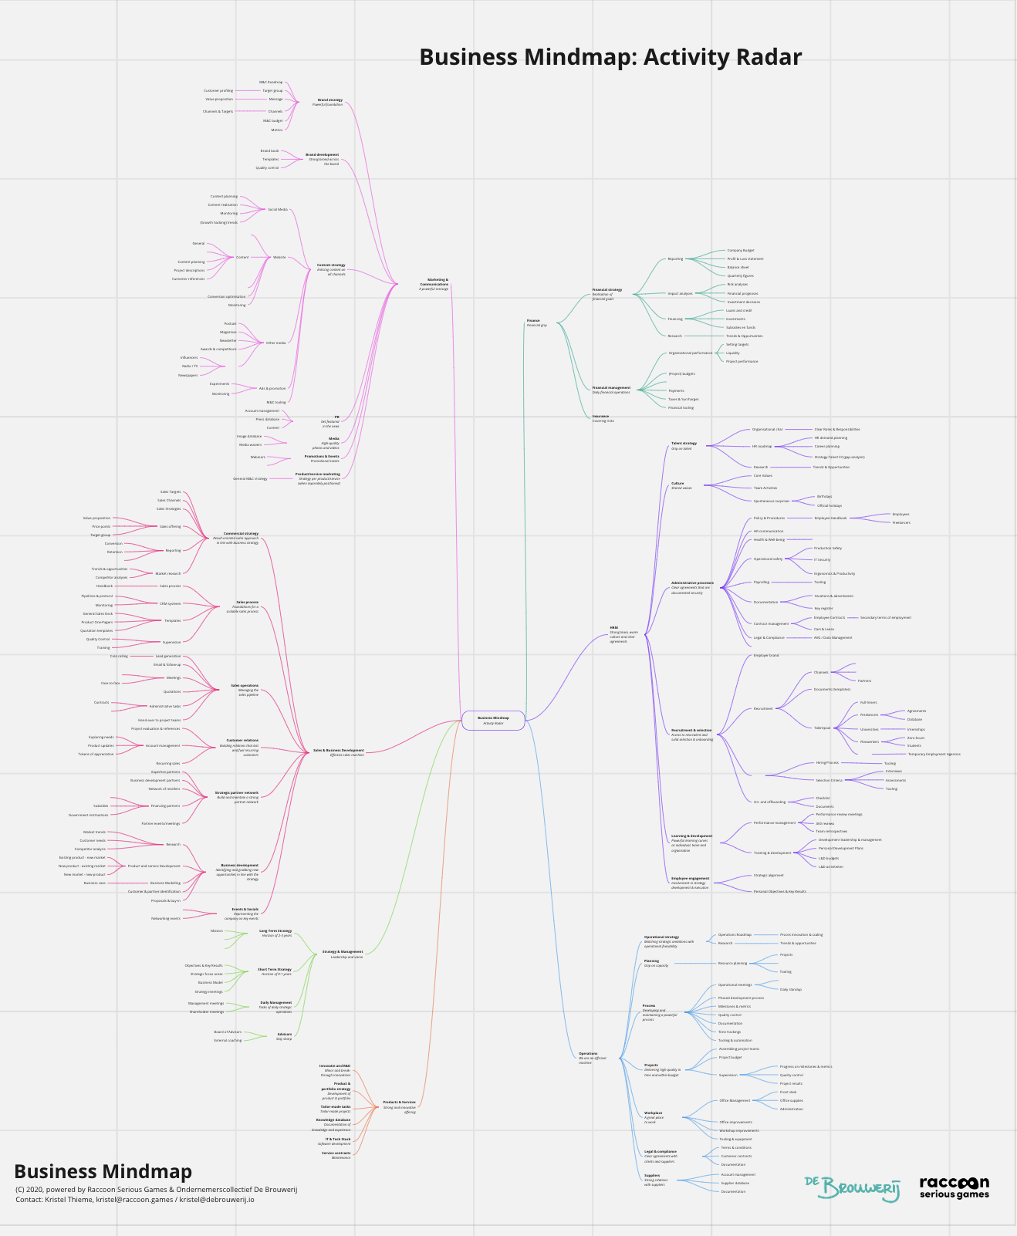

Figure - Facilitated a visual brainstorming workshop to help a Scrum Team better understand their product and organisation context

## LO 2-4 - identify at least three practices for facilitating remote meetings

Techniques I have used to facilitate remote meetings are:

1. Ice breakers – build a strong personal connection between new remote team members
2. Go Around – during daily scrum for a remote scrum team, I ensure every team member speaks and other practise active listening
3. Use breakout room – during workshops for remote teams, I use breakout rooms to facilitate discussion in small groups
4. Whiteboarding – I use a lot of visual aids in Miro to facilitate remote meetings
5. Liberating structure – I employ liberating structure when facilitating remote meetings. Examples include – 1-2-4-All, conversation café, 9 whys

## LO 2-5 **create** a coaching agreement with an individual or a team- (living document).

Context: I work as a Delivery Lead / Scrum Master helping to deliver enterprise data services through Agile and non-agile teams. I am passionate about training, mentoring and coaching people are transition or transforming their careers towards agile tech, data and investment space. Currently, I started coaching Terry (an acquaintance of a friend) who graduated from. UK university with a degree in Finance and Economics and wants to become a data analyst. Here is the starting coaching agreement

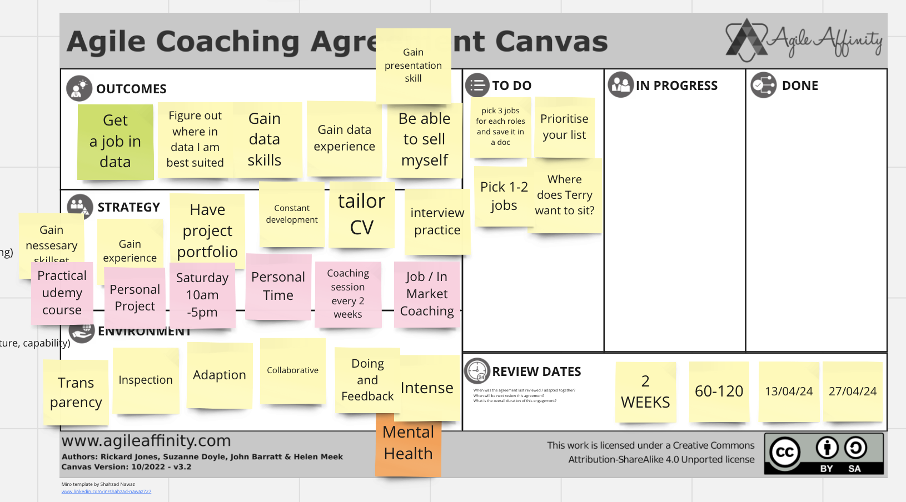

Figure – Agile coaching agreement with Terry who wants to become a data analyst

## LO 2-6 - discuss the importance of at least 2 fundamental coaching assumptions

The coaching stances provides 9 key fundamental coaching assumptions. Champion et. al proposed the 9 coaching stances in their paper “Principles and Dynamics of Matching Role to Situation” in order to help clients achieve their goals.

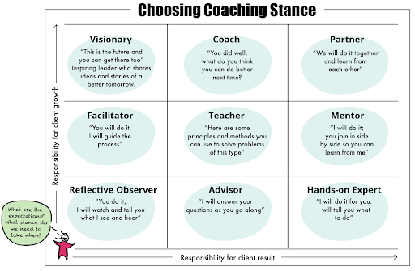

Figure - <https://dandypeople.com/blog/agile-coaching-in-a-nutshell/>

Three key assumptions from the Coaching Stance are:

1. Coach as a Reflective Observer
2. Coach as a Facilitator
3. Coach as a Visionary

### Assumption 1 - Coach as a Reflective Observer

1. Coach takes a reflective observe stance as a coach
2. Coach pays attention to interactions, reactions, attitudes, and moods, giving their perspective and analysis on what they have seen or use them contextually.
3. Coach as a reflective observer impacts very lightly on the growth and results

Key importance – providing neutral and non-bias observation to an individual, team, and organisation

### Assumption 2 – Coach as a Facilitator

1. Coach applies their knowledge of meeting conceptualization, structuring, facilitation, moderation, conflict resolution and navigation scenarios, group dynamics evaluation, and workshops to the meeting
2. Coach helps achieve specified goals or develop new ways to improve the efficiency of existing meetings and events
3. Coach as a facilitator improves growth and not results

Key importance – help individual, teams, and organisation reach a conclusion, make a decision, and navigate conversations better

### Assumption 3 – Coach as a Visionary

1. Visionary Coach has clear vision for the future, actively question the status quo, and inspire others to follow in their footsteps
2. Visionary coach is unrelenting in focusing on what could be rather than what is
3. Coach as a Visionary only helps with growth

Key importance – encourages and motivates individuals, teams and businesses to achieve more

Source

1. What Is Your Coaching Stance? - <https://big-agile.com/blog/what-is-your-coaching-stance>

## LO 2-7 **list** at least three fundamental psychological concepts that help transform individual behaviour.

Fundamental psychological concepts that help transform individual behaviour are:

1. **DiSC styles** – stands for four main personality profiles – **D**ominance (D), **I**nfluence (I), **S**teadiness (S) and **C**onscientiousness. DiSC self-assessment will help individuals, teams and enterprises understand their peoples’ strength and limitation. In order, it helps with understanding where people psychological gravitate toward most (their comfort zone). DiSC empowers individuals, teams and enterprises understand peoples’ underlying psychological tendencies and psychological preferences. Furthermore, DiSC helps adapt psychological behaviours with other more effectively
2. **Growth Mindset** – “A growth mindset is when students [individuals, teams and enterprises] understand that their ability can be developed” Prof. Carol Dweck. The growth mindset enables and empowers 6 psychological elements:
   1. Intelligence can be developed
   2. Embrace challenges
   3. Persist in the face of setbacks
   4. See effort as path to mastery
   5. Learn from criticism
   6. Find inspiration in the success of others
3. **DRIVE** – proposes a new psychological motivational approach with three key elements:
   1. Autonomy – desire to direct our own lives
   2. Mastery – urge to get better and better at something that matters
   3. Purpose – yearning to do what we do in the service of something larger than ourselves

Source

1. DiSC styles - <https://www.discprofile.com/what-is-disc/disc-styles>
2. Mindset – Dr. Carol S. Dweck
3. 5 1/2 Things About Growth Mindset From Dr. Tromp - <https://www.boisestate.edu/student-life/5-1-2-things-about-growth-mindset-from-dr-tromp/>
4. Drive: The Surprising Truth about What Motivates Us by Daniel H. Pink
5. Drive by Daniel H. Pink - <https://www.samuelthomasdavies.com/book-summaries/business/drive/>

## LO 2-8 - **develop** and teach at least one topic related to Scrum or Agile.

I developed and teach an introduction to Agile within my organisation

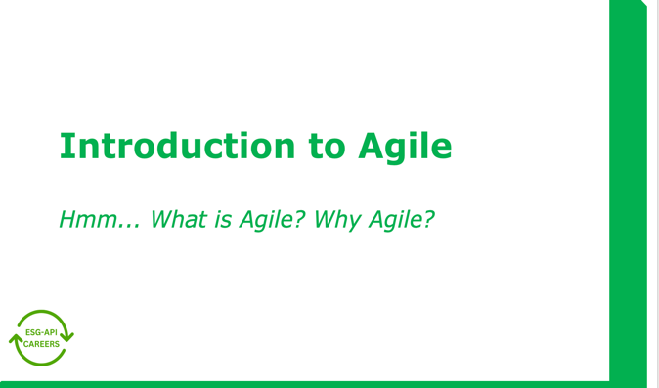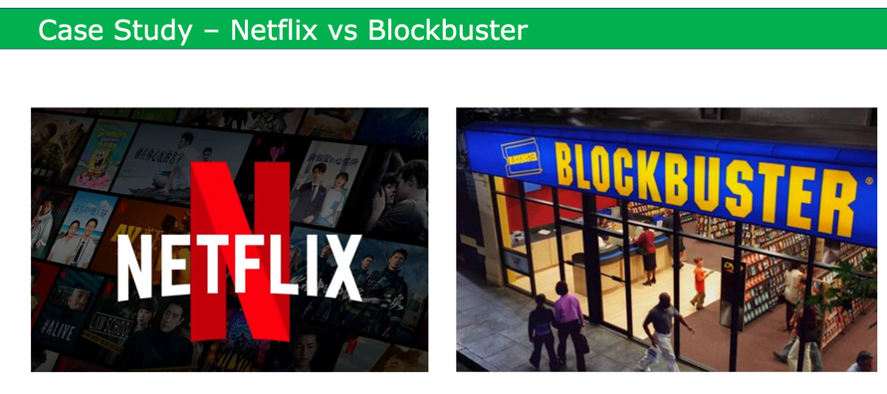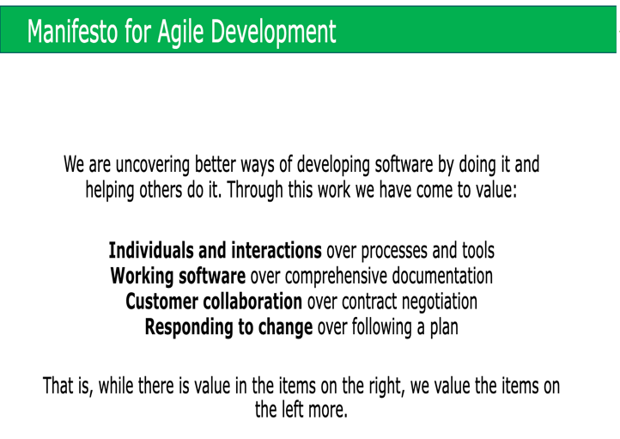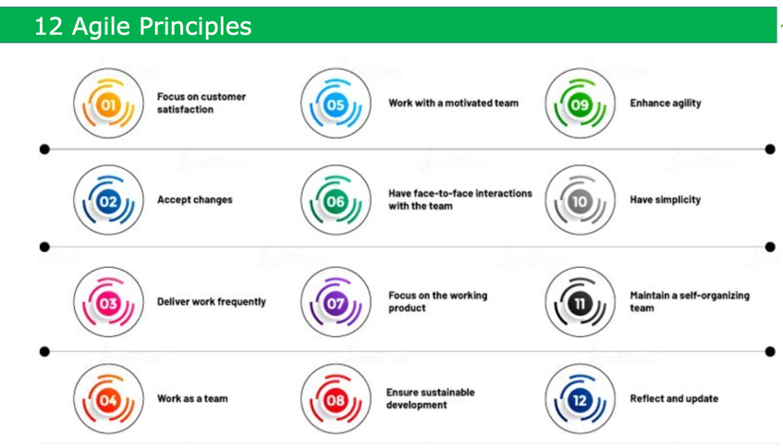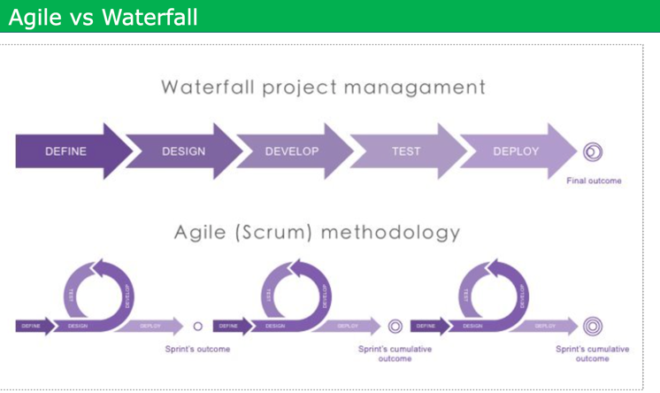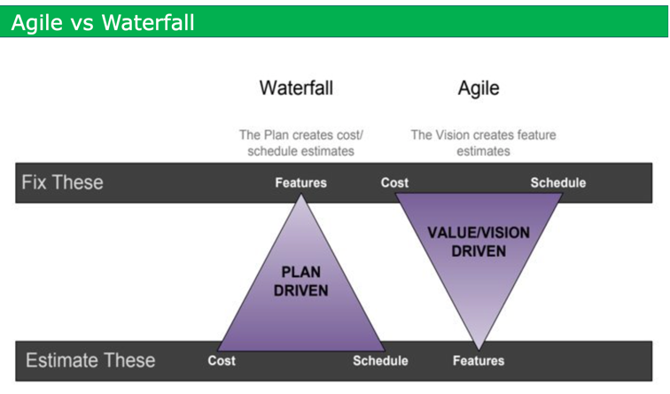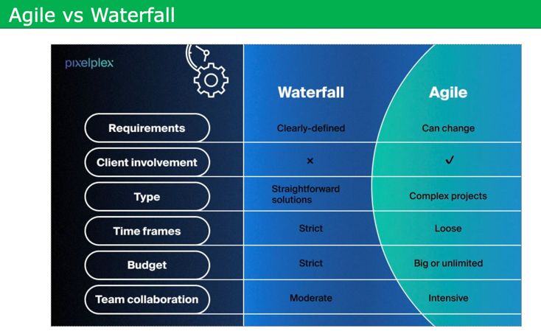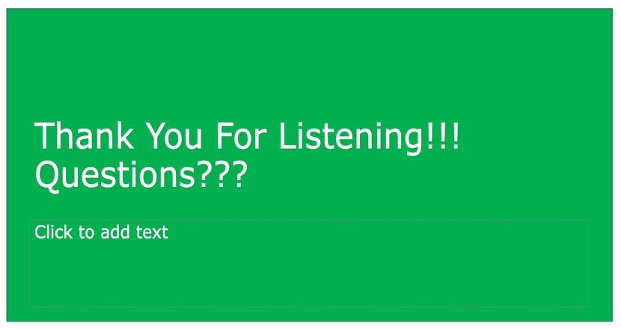

Figure - Workshop - Introduction to Agile

# Service to Scrum Team

## LO 3.1 - **appraise** at least two different models for team development

Different team development models include:

1. Forming-storming-norming-performing-adjourning (FSNPA) model
2. Lencioni Model
3. GRPI Model
4. Katzenbach and Smith Model
5. T7 Model
6. LaFasto and Larson Model
7. Hackman Model

### Forming-storming-norming-performing -adjourning (FSNPA) model

FSNPA model was proposed by Psychologist Bruce Tuckman in his 1965 paper – Developmental Sequence in Small Groups where he described how team move through five distinct stages as they evolve from a collection of individuals to a more cohesive unit:

1. **Forming** – team members come together to meet, set their goals, and understand their roles
2. **Storming** – team members experience conflict as they learn more about each other’s work and communication styles
3. **Norming** – Team members starts to reach a place of more harmony, better understand their strengths and weakness, and fall into a routine with each other
4. **Performing** – Team members are working well together and delivering business value
5. **Adjourning** – team members go their separate ways

|  |  |
| --- | --- |
| **Pros** | **Cons** |
| Provides a framework for knowing the natural phases of a team’s development | Focuses exclusively on new team |
| Easier to guide a group effectively based on identified stage | Provides little direction / context about what to do if a team is stuck in a certain stage |
| Allows for easily pinpoint what stage a team is currently in | Doesn’t provide much context for long-standing teams who work together continuously but might have various members coming and going |

Table - Pros and Cons of FSNPA Model

Personal View - Overall, I am a practitioner of FSNPA model has it helps me guide, lead and coach a team during different stages of their development

### Lencioni Model

The Lencioni model provides pyramidic framework for understanding what doesn’t make a successful team in his seminar book – The Five Dysfunctions of a Team. Lencioni propose five factors that could ultimately lead to a team’s downfall:

1. **Absence of trust** – team members don’t feel that they can be comfortable, honest, and vulnerable to maintain harmony
2. **Fear of conflict** – team members are afraid to rock to boat in order to maintain harmony
3. **Lack of commitment** – team members aren’t devoted to the team’s goal and their work together
4. **Avoidance of accountability** – team members don’t recognize, respect, or appreciate the role they each play in their collaboration
5. **Inattention to results** – team members lose sight of the bigger picture of what they’re working toward together

|  |  |
| --- | --- |
| **Pros** | **Cons** |
| Provides a framework for identifying sources of their dysfunction in a team | Not based on research or empirical evidence |
| Give leaders, scrum master, and agile coaches an actionable list of pitfalls to avoid when establishing new teams | Doesn’t provide a robust framework into how leaders can actually address the common dysfunctions |

Table - Pros and Cons of the Lencioni Model

Personal view – I have been deeply influenced by Lencioni Model when helping individuals, teams and organisations [especially start-ups] navigate conflict and challenging times. Overall, I encourage and challenge teams and leaders – both agile and non-agile leaders to read and practice Lencioni Model.

**Reference**

1. What strong teamwork looks like: 7 proven models - <https://www.atlassian.com/blog/teamwork/what-strong-teamwork-looks-like>
2. Forming-storming-norming-performing-adjourning (FSNPA)model
3. Tuckman, B.W. (1965). 'Developmental Sequence in Small Groups,' Psychological Bulletin, 63(6)
4. The Five Dysfunctions of a Team: A Leadership Fable - <https://amzn.eu/d/fryATuD>

## LO 3.2 **compare** at least 3 techniques for improving team effectiveness

|  |  |  |
| --- | --- | --- |
| **Technique** | **Overview** | **Difference From others** |
| Sprint  Retrospective | * Help scrum teams plan ways to increase quality and effectiveness * Scrum teams inspects how the last Sprint went with regards to individuals, interactions, processes, tools, and their Definition of Done * Scrum Team identifies the most helpful changes to improve its effectiveness * most impactful improvements are addressed as soon as possible | * Fosters team effectiveness using reflection * Creates a continuous improvement and continuous feedback loop for a scrum team to improve team effectiveness * Focus on improving individuals, interactions, processes, tools, and their Definition of Done * At least 1 action items is identified to be actioned * Mandatory scrum event |
| Brown  Bag | * Informal training and learning session * Topics for brown bag meetings can be work-related or geared to help employees with their lives outside of work * Takes place in the workplace, generally around lunch time * Foster the sharing of information and teamwork | * Fosters team effectiveness using learning * Focusses on improving team effectiveness using informal training and learning sessions * Promotes continuous learning culture * Promote knowledge transfer * Informal in nature |
| Encouraging Healthy conflict | * Viewing disagreements as a problem to be solved collaboratively * Focus on the issue and not the individual * Team members practise active listening * Promotes constructive feedback over criticising people | * Fosters team effectiveness using conflict * Acknowledges different perspectives * Reach better solutions by challenging different view points * Encourage healthy dialogue and debates * Increases trust |

Table - Techniques for improving team effectiveness

Reference

1. The 2020 Scrum Guide - <https://scrumguides.org/scrum-guide.html>
2. What Is a Brown Bag Meeting? Definition, Types and Key Benefits - <https://www.investopedia.com/terms/b/brown-bag-meeting.asp>
3. Unhealthy conflict vs healthy conflict - <https://addyosmani.com/blog/healthy-unhealthy-conflict/#:~:text=Here's%20what%20characterizes%20healthy%20conflict,listen%20to%20each%20other's%20perspectives>.
4. Why Healthy Workplace Conflict Is Productive - <https://www.forbes.com/sites/carolinecastrillon/2023/04/23/why-healthy-workplace-conflict-is-productive/>

## LO 3-3 - **describe** at least five responsibilities for Scrum Team members and stakeholders when forming a new Scrum Team.

The responsibilities of a Scrum Team members and stakeholder when forming a new Scrum Team are:

1. **Establish a clear Product Vision** – the Scrum Team members and stakeholders need to create a clear and agreed purpose for creating the product. They need to understand the positive change the product will bring about. The product vision provide an emotional and practical connection between the Scrum Team and Stakeholders
2. **Establish a clear Product Strategy** – Scrum Team members and stakeholders need to understand how they will realise the product vision and achieve product success [even if there is a lot of assumptions to start with]. There needs to be a working and agreed understand around the Needs, Market, standout features and business goals
3. **Establish a clear [and crude] starting Product Roadmap** ­- Scrum Team members and stakeholders need to set a crude working agreement on how to implement the strategy over the next common months. There needs to be a clear working expectation around Product goals, timeframes, selected coarse-grained features, and guiding metrics
4. **Create a Product Backlog** - Scrum Team members and stakeholders have to decided and prioritise starting features required to achieve the next product goal. They need to create epics, user stories, work flow diagrams, mocks-ups, non-functional requirements and any key starting artefacts.
5. **Establish Scrum ways of working** – with the support of the Scrum Master, the Scrum Team members and stakeholders have to start establishing Scrum as defined in the Scrum guide. They do this by understanding Scrum theory and practise. The Scrum Master is accountable for establishing Scrum.

Reference

1. Strategise: Product Strategy and Product Roadmap Practices for the digital age
2. What is a Product Vision - <https://www.scrum.org/resources/what-product-vision>
3. The 2020 Scrum Guide - <https://scrumguides.org/scrum-guide.html>

## LO 3-4 - **plan** the launch of a new Scrum Team.

**Context**: In a previous organisation, I worked as Product Manager within a sales and marketing team. Our product goal was to create an intelligent CRM Flywheel dashboard for customer analytics. I was responsible for planning the launch of a new Scrum Team. I used Team Canvas Basic to plan launch of Team Flywheel.

Team Canvas Basic Session

**Objectives**

* Get new Scrum Team to agree core team fundamentals and get to know each other better
* Helps the new team set and understand the following: purpose, goal, values, roles & skills, and rules and activities

**Duration**

* 90 minutes (+ 30 minutes if required)

**Steps**

1. Step 1 - Create a team name
2. Step 2 – Create goals
3. Step 3 – create values
4. Step 4 – create roles & skills
5. 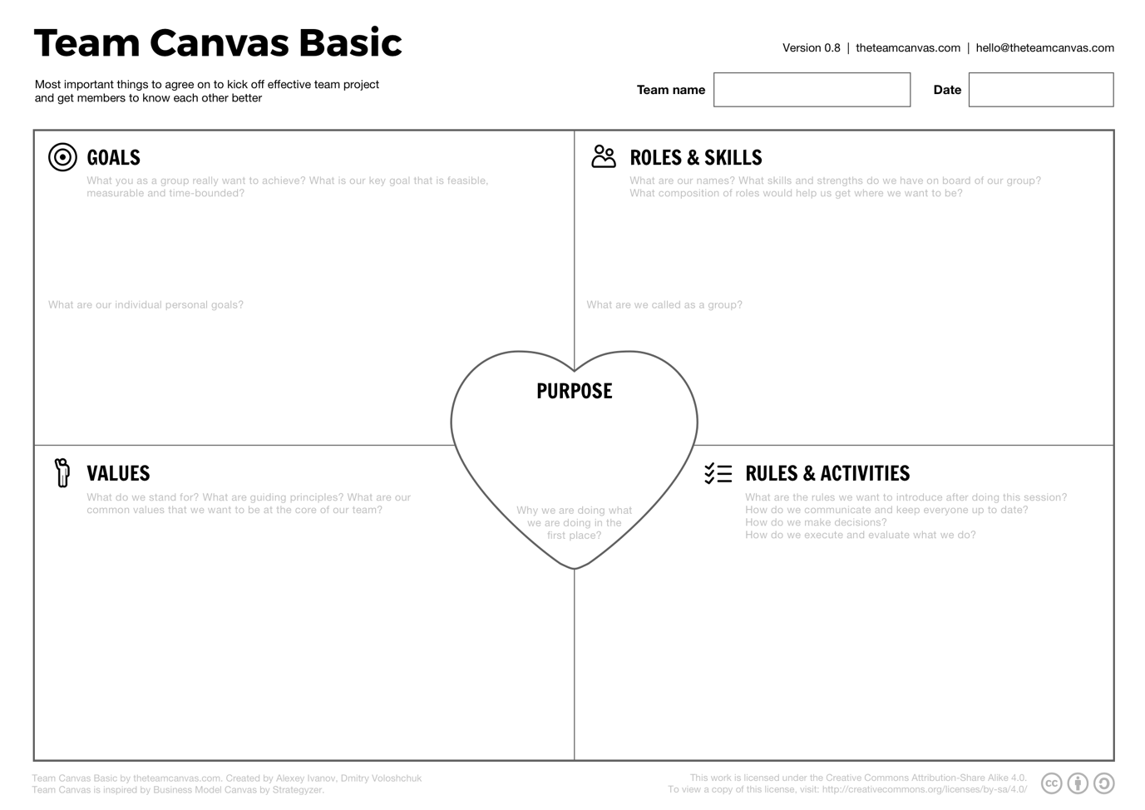Step 5 – set rules and activities

Table - Team Canvas Basic template

# Service to the Product Owner

# Service to the Organisation

# Advanced Scrum Master

## LO 6-1 Outline a personal development strategy toward Scrum Mastery

### Context

Context: I work as a Delivery Lead / Scrum Master helping to deliver enterprise data services through Agile and non-agile teams. I am passionate about enterprise and team agility and value flow. I would love to coach CxO and Leaders on organisation agility and large-scale agility.

### Experience Path

1. Deepening my scrum mastery experience across
   1. Different value types
   2. Different business departments & organisations
   3. Different use cases
   4. Different technologies

### Certification Path

1. Follow the Scrum Master path in Scrum Alliance
   1. Certified Scrum Master – Done
   2. Advanced Certified Scrum Master – Done
   3. Certified Scrum Professional – Scrum Master – In Progress
2. Follow the Product Owner path in Scrum Alliance
   1. Certified Scrum Product Owner – Done
   2. Advanced Certified Scrum Product Owner – Done
   3. Certified Scrum Professional – Product Owner – To Do
3. Scaled Agility
   1. SAFE Scrum Master – Done
   2. SAFE Consultants – To Do
   3. Less Basic – To Do
   4. Less Practitioner – To Do
4. Coaching & Training
   1. Certified Team Coach – To Do
   2. Certified Enterprise Coach – To Do
   3. Certified Scrum Trainer
   4. ICF Associate Certified Coach – To Do
   5. ICAgile Coaching Certification – To Do

### Peer Growth

1. Agile Coach – Monthly check-in – In Progress
2. ABC group – Agile Book Club – In Progress
3. Scrum Master Community of Practices - In Progress
4. Scrum Meetup – In Progress

### Writing & Lecture

1. Writing scrum mastery blogs – To Do
2. Writing scrum related use cases – To Do
3. Give public lectures and seminars on Scrum Mastery and Organisation agility – To Do

## LO 6-2 practice mentoring someone.

***Case Study – From Engineering Project Manager to Scrum Master***

**Context**

I was working as a Scrum Master / Tech Lead for one of the leading sustainable asset managers when I was approached by a friend who was an engineering with project management experience and wanted to transition into becoming a Scrum Master

**Goal**

Mentoring to transition from Engineering Project Manager to Scrum Master

**Action**

1. Provided guidance on understanding Agile and Scrum
2. Provided 1 on 1 training and coaching on Agile and Scrum practises
3. Created a learning practical project to apply agile and scrum technique
4. Review CV
5. Conducted mock interviews

**Outcome**

1. Transitioned from Engineering Project Manager to Scrum Master
2. Transitioned from waterfall ways of working to working as a Scrum Master across multiple teams
3. Improve life satisfaction and job satisfaction